**JOIN MULTIPLE TABLE**

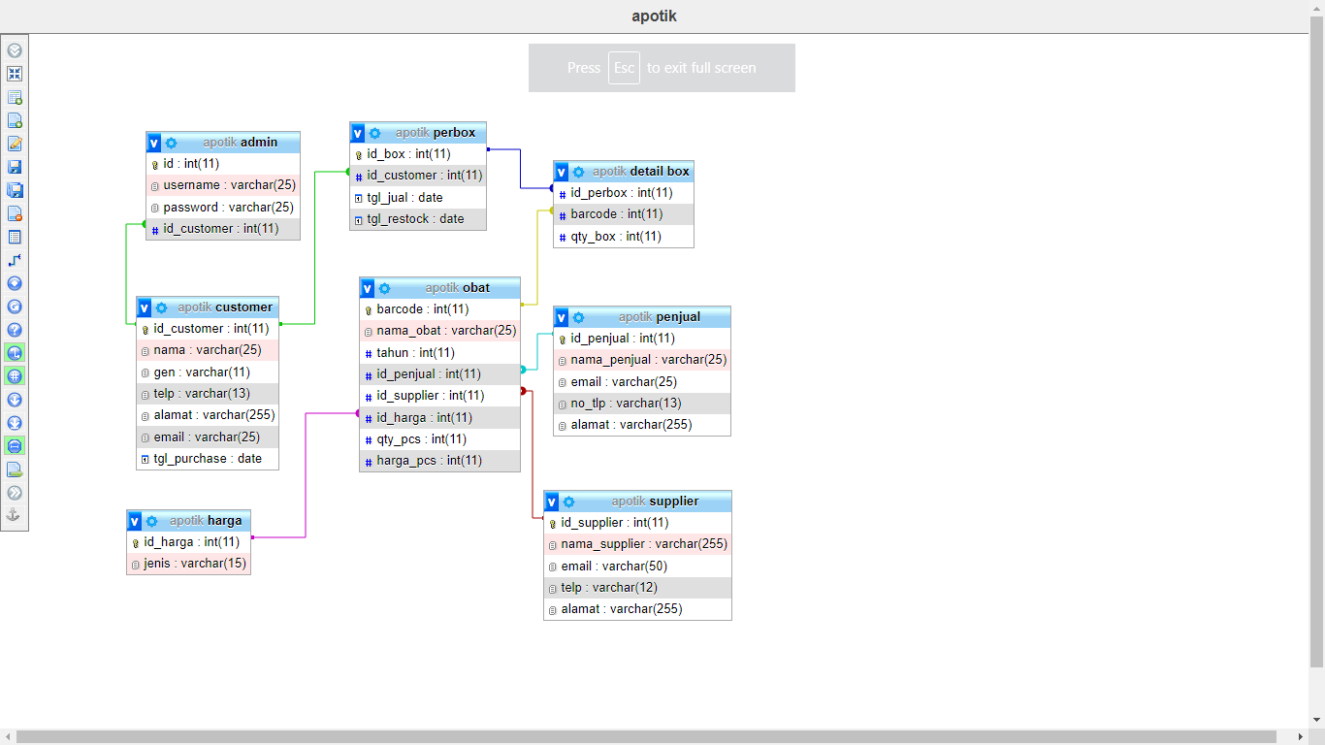

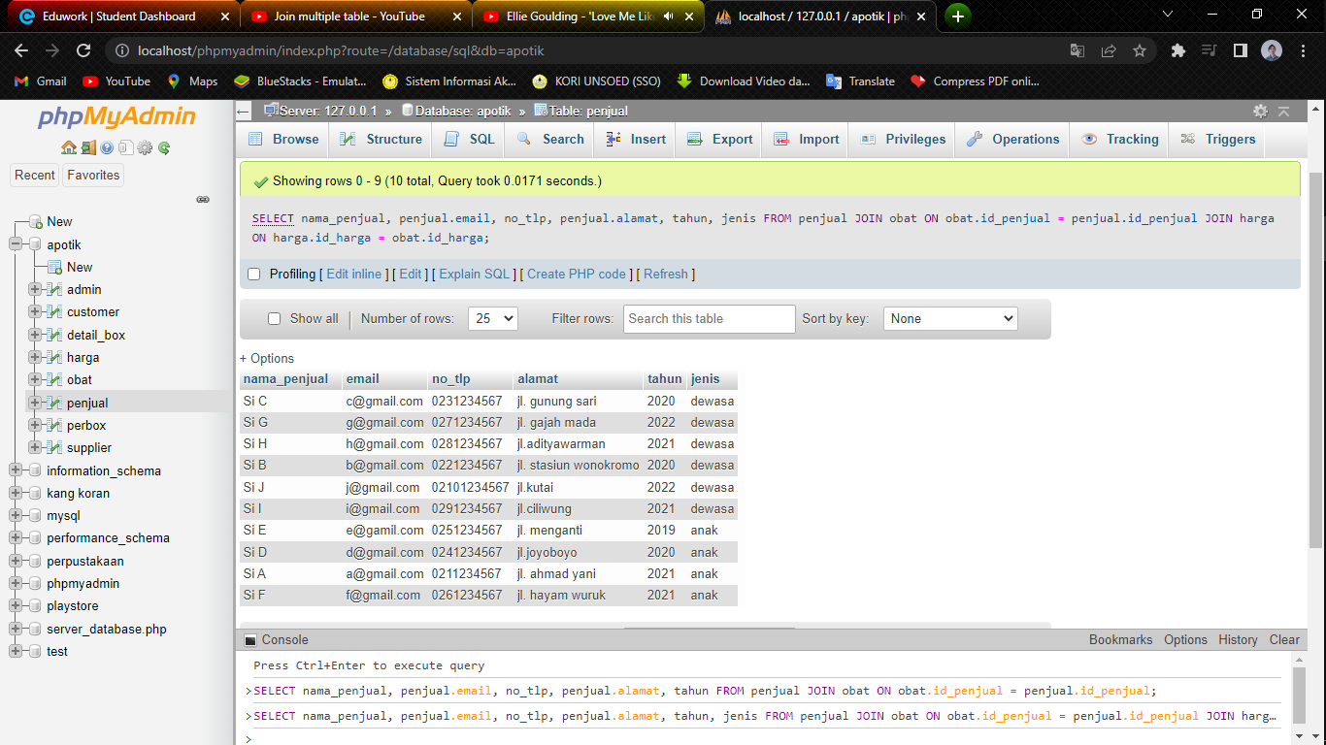

SELECT nama_penjual, penjual.email, no_tlp, penjual.alamat, tahun, jenis

FROM penjual

JOIN obat ON obat.id_penjual = penjual.id_penjual

JOIN harga ON harga.id_harga = obat.id_harga



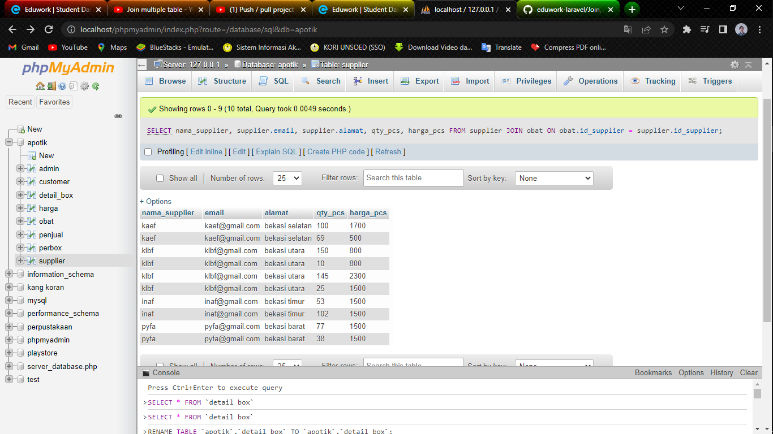

SELECT nama_supplier, supplier.email, supplier.alamat, qty_pcs, harga_pcs

FROM supplier

JOIN obat ON obat.id_supplier = supplier.id_supplier



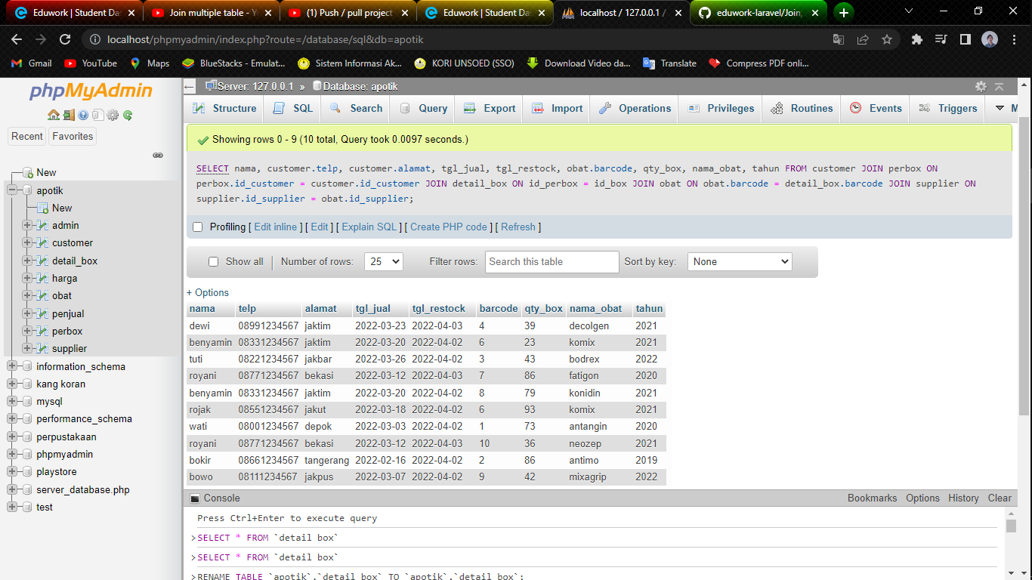

SELECT nama, customer.telp, customer.alamat, tgl_jual, tgl_restock, obat.barcode, qty_box, nama_obat, tahun

FROM customer

JOIN perbox ON perbox.id_customer = customer.id_customer

JOIN detail_box ON id_perbox = id_box

JOIN obat ON obat.barcode = detail_box.barcode

JOIN supplier ON supplier.id_supplier = obat.id_supplier